class Pet:

def __init__(self, name, hunger=5, energy=5, happiness=5):

self.name = name

self.hunger = hunger

self.energy = energy

self.happiness = happiness

self.tricks = [] # List to store learned tricks

def eat(self):

self.hunger = max(0, self.hunger - 3)

self.happiness = min(10, self.happiness + 1)

print(f"{self.name} has eaten and feels happier!")

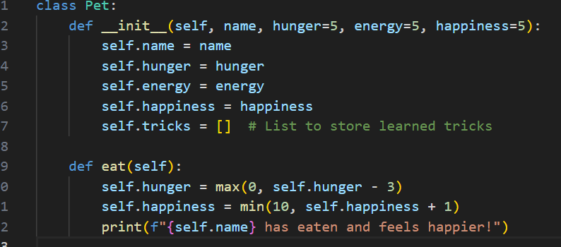

def sleep(self):

self.energy = min(10, self.energy + 5)

print(f"{self.name} had a good rest and feels recharged!")

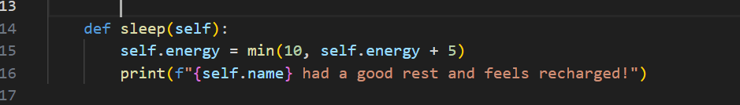

def play(self):

if self.energy >= 2

self.energy -= 2

self.happiness = min(10, self.happiness + 2)

self.hunger = min(10, self.hunger + 1)

print(f"{self.name} had a great time playing!")

else:

print(f"{self.name} is too tired to play and needs to rest.")

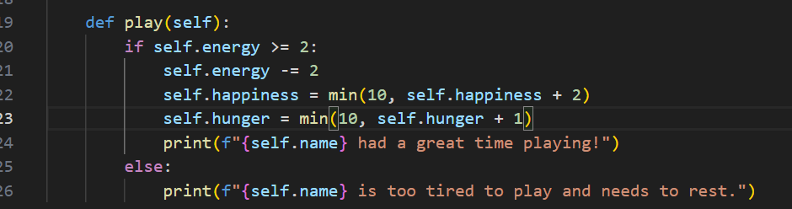

def get_status(self):

print(f"Pet Status - Name: {self.name}, Hunger: {self.hunger}, Energy: {self.energy}, Happiness: {self.happiness}")



def train(self, trick):

self.tricks.append(trick)

self.happiness = min(10, self.happiness + 1) # Training makes the pet happier

print(f"{self.name} has learned a new trick: {trick}!")

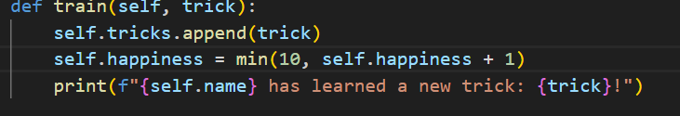

def show_tricks(self):

if self.tricks:

print(f"{self.name} knows the following tricks: {', '.join(self.tricks)}")

else:

print(f"{self.name} hasn't learned any tricks yet.")

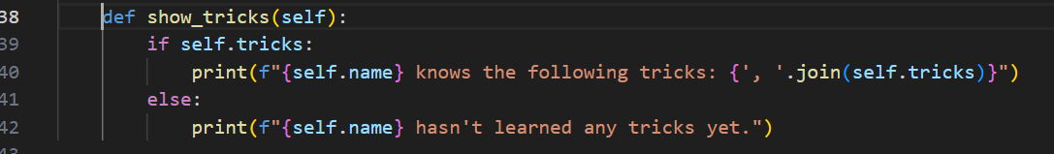

my_pet = Pet("Sphothi")

Sphothi.get_status()

Sphothi.eat()

Sphothi.sleep()

Sphothi.play()

Sphothi.train("Roll Over")

Sphothi.train("Sit")

Sphothi.show_tricks()

Sphothi.get_status()